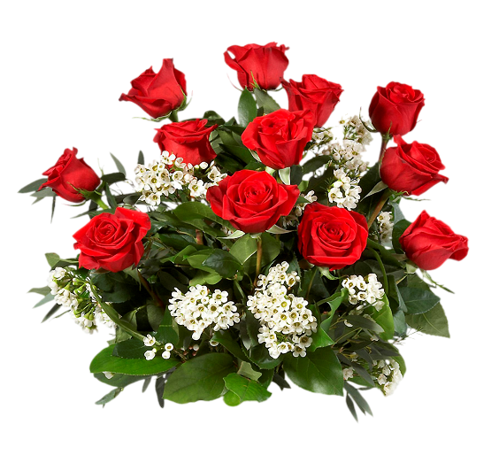

James Adams
Joyce Allen *
Maurel Allen *
Gregory Avent
Erling Bailey
Ronald Bailey
Robert Birdsong
James Bowser
Joseph Brawner
Barbara Brown
Lois Brown
Charlie Brown
Raymond Carroll
William Clark
Kim Claytor
Bob Craig
Donald Duvall
Perry Garrett *
Samuel Gilmer
Shirly Grant
Ernest Gray
Lynn Grigsby
Richard Grigsby
Lottie Hall
Daniel Hazel
William Henderson
Clarence Herring
Clifford Hewlett
Laurette Hewlett
Cheryl Hardy
Myra Hobbs
Harry Jackson
Sylvester Jenifer
Bernetta Jones
Jacque Johnson
Bob Kirby
Walter Lancaster *
Art Lewis

Harold Lewis

(*) Club Founders

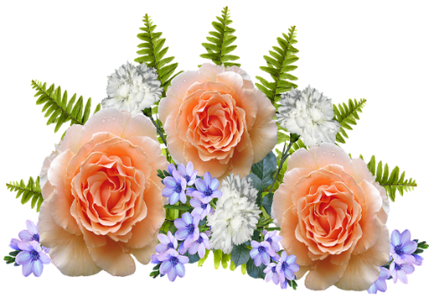

Pattie Lomax
* Charlie Love
Les Love
John Malone
Rhonda Mack
Ruth McLarin
William McLarin
Davis Miller
Dorothy Newborn
Philip Nowlin
French Nickens
Bryce Parks
Robert Palmer
Albert Patterson
Nelson Reeve
* Beverly Reid
* Franklin Reid
Minnie Roane
Ida Robinson
John Robinson
Bob Rogers
Weston Skinner
Gladys Smith
Delores Snowden
Stan Snowden
Alfonzo Spencer
Georgia Spencer
Herbert Stowe
James Stringfield
Doris Walker
William Walker
Clarence Waters
Gary Weems
Allen West
Barbara Whalen
Walter Wheaton
Barbara Whitfield
* Bert Williams

